**PSYC 6135 Final Presentation Proposal**

**Topic: *Using Data Visualization to Improve Neuropsychological Feedback***

**Rationale:**

1. In neuropsychological assessments, the feedback process is often a stage that is met with a lot of anxiety and miscommunication for patients and clients.
2. Neuropsych feedback is an important and integral component of a neuropsych assessment (Gorske & Smith, 2009; Postal & Armstrong, 2013; Rosado et al., 2018)
   1. Offers the opportunity to discuss cognitive strengths and weaknesses
   2. Provides recommendations for daily life functioning
   3. Increases a patient’s quality of life
   4. Increases a patient’s understanding of a diagnosis
   5. Increases coping abilities
3. Despite disseminating supplementary information (e.g., recommendations, written summaries), encouraging patients/clients to reach out after feedback, and clinicians’ attempts to make feedback as digestible as possible, various factors can impact how effective or ‘digestible’ information is, which ultimately impacts how accurately individuals may recall information.
4. As well, there is currently no official, standardized approach to providing feedback.
5. Other challenges related to the feedback process include:
   1. The complex nature of neuropsychological test results (Gorske & Smith, 2009; Postal & Armstrong, 2013)
   2. Information retention of medical information is generally low (Kessels, 2003; Langewitz et al., 2015; Ley, 1988)
   3. Written summaries and information for patients (compared to only verbally sharing feedback)has been found to improve treatment adherence and enhance free recall of neuropsych recommendations (Kessels, 2003, Fallows & Hilsabeck, 2013; Meth et al., 2016). However, neuropsychological reports or summaries may introduce additional roadblocks related to factors such as readability and complexity for laypersons. This is especially difficult for those experiencing cognitive impairments, changes, or low literacy functioning.
6. As such, using new methods to increase understanding of neuropsychological test results through feedback may enable clients to make positive adjustments, understand their diagnoses more clearly, and ultimately increase the efficacy and satisfaction with feedback and assessment processes in general.
7. It is essential that accurate and clear communication is at the forefront of feedback sessions (along with empathy and client-centered approaches); thus, our goal is to **use data visualization methods to improve the feedback process**.

**Related Research:** *Gruters, A. A. A., Ramakers, I. H. G. B., Stiekema, A. P. M., Verhey, F. R. J., Kessels, R. P. C., & de Vugt, M. E. (2021). An exploratory study of the development and pilot testing of an interactive visual tool of neuropsychological test results in memory clinics. Journal of Alzheimer’s Disease, 79, 1157-1170*

1. Study Aim:
   1. Develop a web-based visual tool for neuropsych test results to increase the understanding of neuropsych performances, to improve information retention, and to support communication during feedback sessions
   2. Second aim: determine the usability, technology acceptance, and feasibility of the tool.
2. Study Methods:
   1. Visual tool co-created with patients, fam members, neuropsych experts.
   2. Examined patient and family member’s views of the tool as well as differences in information retention between those who received the tool vs. didn’t.
3. Visualization Outcomes:
   1. See Appendix for Gruters et al.’s (2021) patient and neuropsychologist tools
4. Both patients and family members gave positive feedback related to the visual tool; however, there was no evidence that retention of the information improved. In fact, retention remained low and not significantly different from those who did not receive the tool.
5. All participants thought the benefit of the visual tool included seeing cognitive strengths and weaknesses with a translation to daily life all at one glance and receiving feedback on paper to take home.

**Our Goals and Implications:**

1. There is evidence for the effectiveness of visual aids across other medical fields:
   1. Visual aids enhance the recall of spoken medical instructions (Houts et al., 1998; 2001)
   2. Visual aids also improved the understanding of medical instructions, especially when a combination of written, visual, and verbal instructions are used (Katz et al., 2006)
2. Our goals include to create different ‘feedback choices’ that incorporate a variety of patient and client factors, including but not limited to:
   1. Cultural factors
   2. Accessibility considerations (e.g., hearing, vision, etc.)
   3. Diagnosis type (and symptomology, e.g., memory impairment, attention deficits, etc.)
   4. Learning considerations (i.e., learning or intellectual disorders)
3. We also hope to include feedback visualizations that will be helpful for both patients and their families/caregivers
4. Our implications are largely that implementing a patient-friendly tool to visualize neuropsychological test performance and data could enable neuropsychologists to deliver patient-tailored information, ultimately improving patients’ understanding of their cognitive strengths and weaknesses, diagnoses implications, and relevant recommendations to encourage treatment adherence.

**Presentation Objectives:**

1. Introduce feedback processes and explain the difficulties, gaps, and issues with feedback
2. Review client factors
3. Introduce visualization tool and creation process
4. Show examples of visualization tools
5. Prepare and present a fake case, and demonstrate how previous feedback would work with the client, and how our new approach to feedback would work
6. Discussion around the tool, and comparing previous approaches to our new approach
7. Discuss our quality assurance methods (i.e., having pre and post measures with patients (and collateral) when appropriate to assess effectiveness of tool and facilitate continued improvement

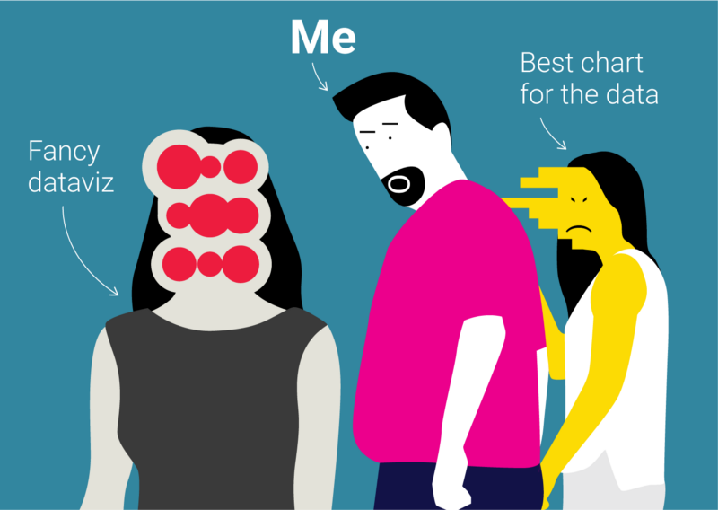

Appendix

Figure 1. Gruters et al. (2021) ‘patient visual tool’

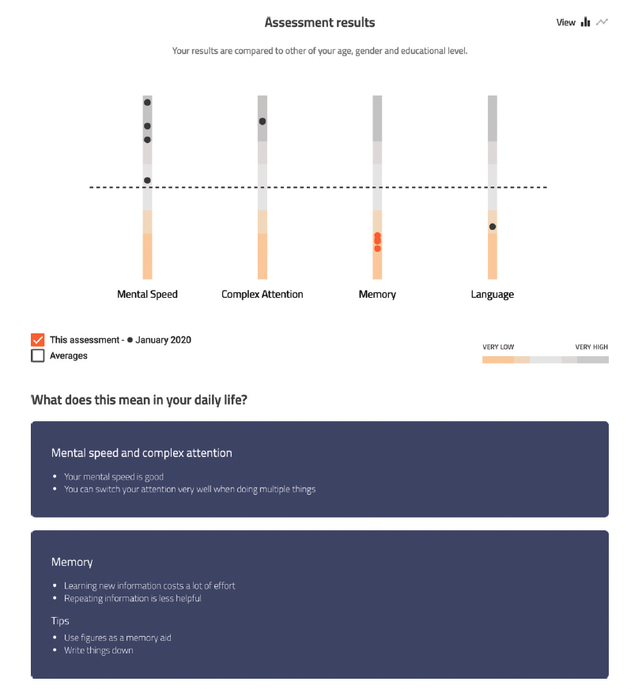

Legend: Figure 1 shows the results of the most recent assessment on the domains of mental speed, complex attention, memory, and language. Each dot in the bar above the cognitive domains represents the score on a subtest. An orange dot indicates a performance lower than minute 2 standard deviations. Below the figure the translation to daily life functioning can be found.

Figure 2. Gruters et al. (2021) ‘neuropsychologist’s visual tool’

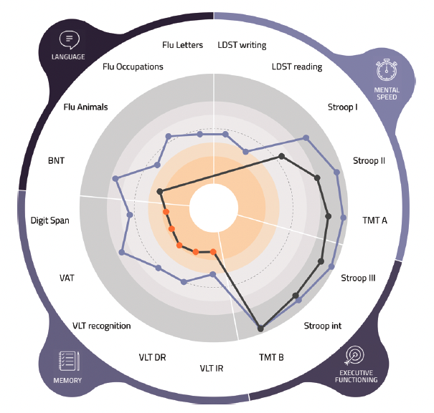

Legend: Figure2 shows the results of an assessment. Similar to Figure 1, the domains of mental speed, executive functioning (i.e., mental speed), memory, and language are included. Within the second layer of the circle are the neuropsychological tests that measure these cognitive domains, with patient performance falling within the center of the circle.